Occupational Therapy
Name
Course
Date

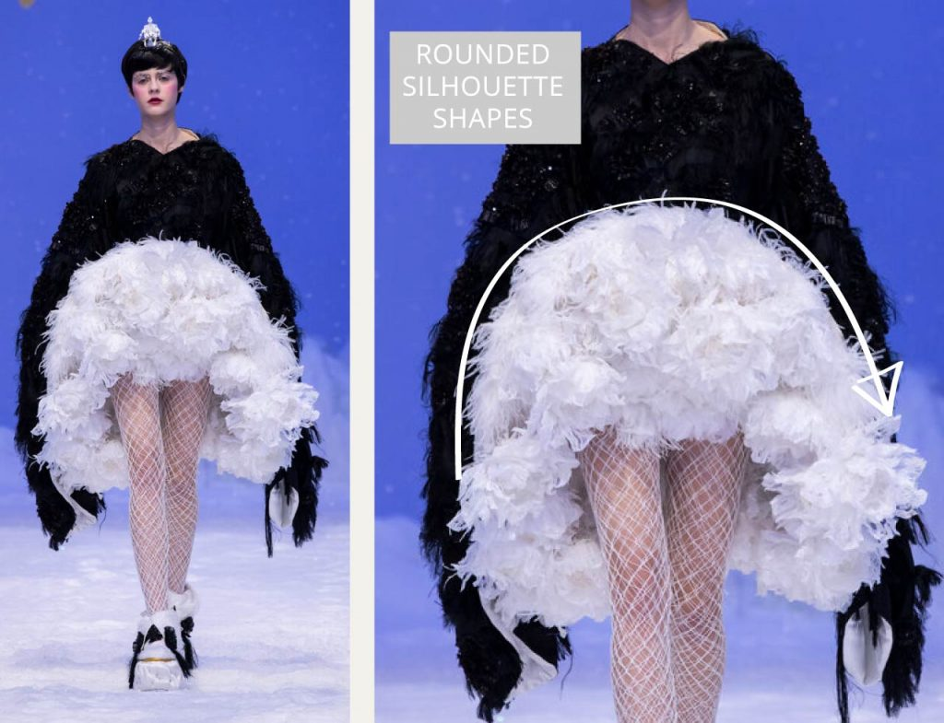
Elements and principles of design
Any good designer manages to use the fundamental elements of design to create a strong, unified and dynamic composition. The piece above is from the Dior Spring-Summer 2020 collection. In my opinion, it incorporates the elements of shape, space, colour and texture to create a balanced and outstanding visual piece. Shape, in fashion design refers to form of the garment i.e. its silhouette. This dress has rounded silhouette shapes to create extreme volume. The shape is more organic than geometric giving it a soft, serene, calm and feminine appearance. As the first thing people usually notice about a garment is its colour. This dress uses black and white, which are neutral colours. However, the use of these 2 colours together creates a contrast that makes the individual colours pop out more and makes the dress stand out. The dress also has a unique texture mainly because of the fabrics that have been used to make it. The texture is tactile, because of the use of coarse and stiff materials, giving the dress an actual 3D texture. In regards to the principles of design incorporated by the designer, the dress shows emphasis. This is because of the fabrics used, the use of contrasting colours and the use of rounded shapes. In terms of rhythm, the dress has a rather graduated rhythm. This dress also manages to achieve harmony in a unified way; the design seems whole.

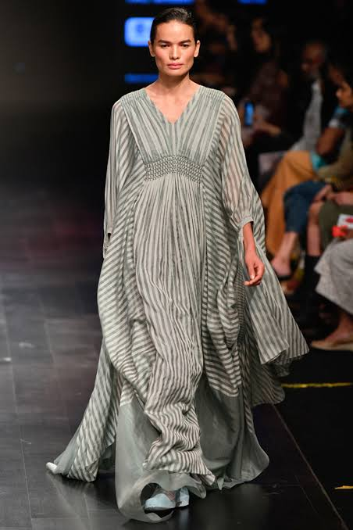
Elements and principles of design
The item in the picture is a grey draped kaftan dress by Aashni + Co. It incorporates several elements and principles of design. Any good designer manages to use the fundamental elements of design to create a strong, unified and dynamic composition. Elements of design include; line, shape, colour, texture and space. Lines form the starting point of most artistic creations and can therefore be regarded as the most fundamental element of design. Lines create a sense of movement and draw the audience’s eyes side to side or up and down. The kaftan has vertical lines which accentuate the model’s height and convey strength. Shape, in fashion design refers to form of the garment i.e. its silhouette. The silhouette is a straight column or tubular silhouette and makes draws attention and smoothens out body lines. The colours on the kaftan are neutral, adding to its elegance. In regard to the principles of design incorporated, the kaftan achieves regular rhythm through the repetition of lines and colours. Harmony is also achieved through unity as its silhouette matches the body shape of the model and the garment.

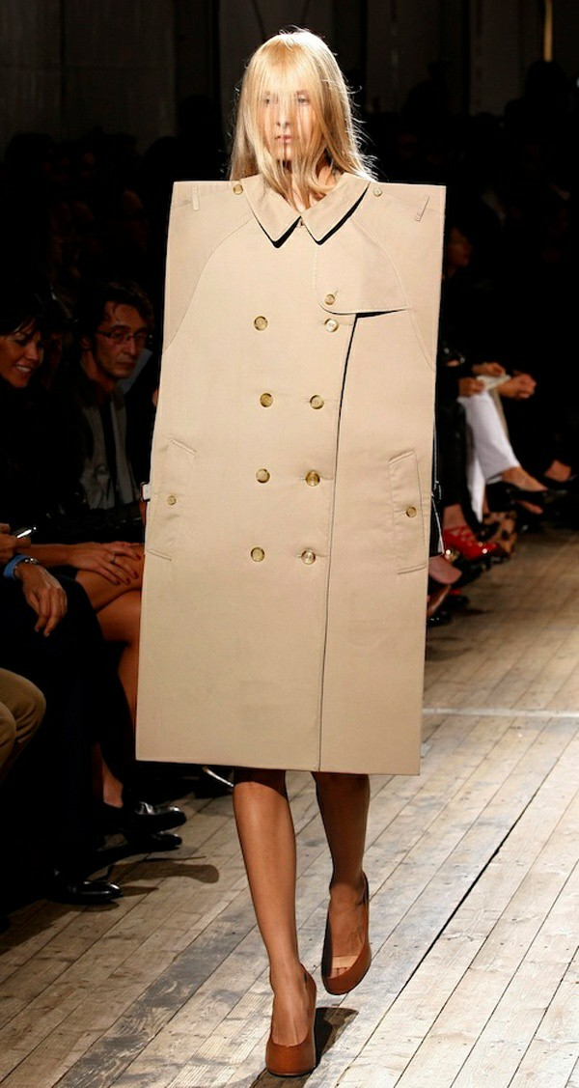
The design above is an example of unsuccessful apparel design. This design does not seem to incorporate any of the elements or principles of design. Elements of design include; line, shape, colour, texture and space. Lines form the starting point of most artistic creations and can therefore be regarded as the most fundamental element of design. Lines create a sense of movement and draw the audience’s eyes side to side or up and down. The design above lacks any form of lines except maybe the outlines used for structural use. For this reason, the design does not appear interesting at all and looks rather bland. This design does not show any consideration of shape as an element of design, there is no defined silhouette. Space is the volume or area a design has around, within, below or above it. Clever use of space may even give a design a 3D appearance. Space and shape have a complimentary relationship as elements of design. In this design, these 2 elements of design do not work together at all and it is hard to figure out what the designer was going for with this design. Colour is also another fundamental element of design. It is the most noticeable thing about a design. The colour used in the design does not stand out. The design also lacks any form of texture. A uniform standard fabric is used throughout. Principles of design include; emphasis, rhythm balance, contrast, harmony and proportion. This design does not use emphasis. There is no contrast between colours and no emphasis through texture. The design does not show any form of balance. It does not have any form of visual stability. There is no rhythm since no element of design has been used repetitively. The design also lacks a sense of completeness hence there is no harmony.

